4 X Idler Assembly

Vitamins
2 Ball bearing 624 4mm x 13mm x 5mm  2 LM8UU bearings  1 M3 cap screw x 35mm  1 M4 cap screw x 25mm  1 M3 cap screw x 18mm  1 Nyloc nut M3 | 1 Nyloc nut M4  2 Washer M3 x 7mm x 0.5mm  2 Washer M4 x 9mm x 0.8mm  1 Nut M3  1 M5 Brass nut

Printed
1 i3xends_v2_Idler.stl  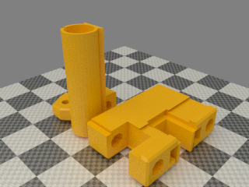 | 1 i3xends_v2_Idler_fork.stl  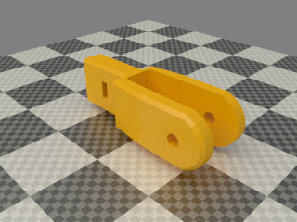 | 1 z_screw_isolator_left.stl  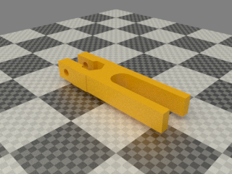

REPLACE 624 normal bearings with flanged type. Fork can rotate and belt will rub on the plastic. Also there is only so much room
LONGER M3 screw needed for for the idler fork

Assembly

- Slide the 2 Idler parts together, they are a VERY tight fit. Don’t worry if they don’t slide completely together. When inserting the X rods they will home the last bit.
- Insert a M3 Nut in the idler fork. Slide it in the idler bits and insert a M3 35mm cap screw with a washers from the end of the idler, make sure the screw engange the nut corretcly.
- Insert the M4 screw and washer through the fork while adding in the following order: 2 624 bearings. Once the screw is through add the final M4 washer and then M4 nyloc.
TIP: wipe the bearings off with paper tissue before mounting them. There might be grease on them. DONT use alcohol etc. just paper tissue and elbow grease-
TIP: if the bearings are loose on the screw add equal amount of M4 washers on the outside of each bearing until the assembly fits snug
- Insert 2 LM8UU bearings, one from the top and one from the bottom.
- Insert a M5 brass nut in the isolator. Put a M3 screw and washer through the isolator and a M3 Nyloc on the other side.
- You should end up with this (note – the bearings was not at hand when making the manual):
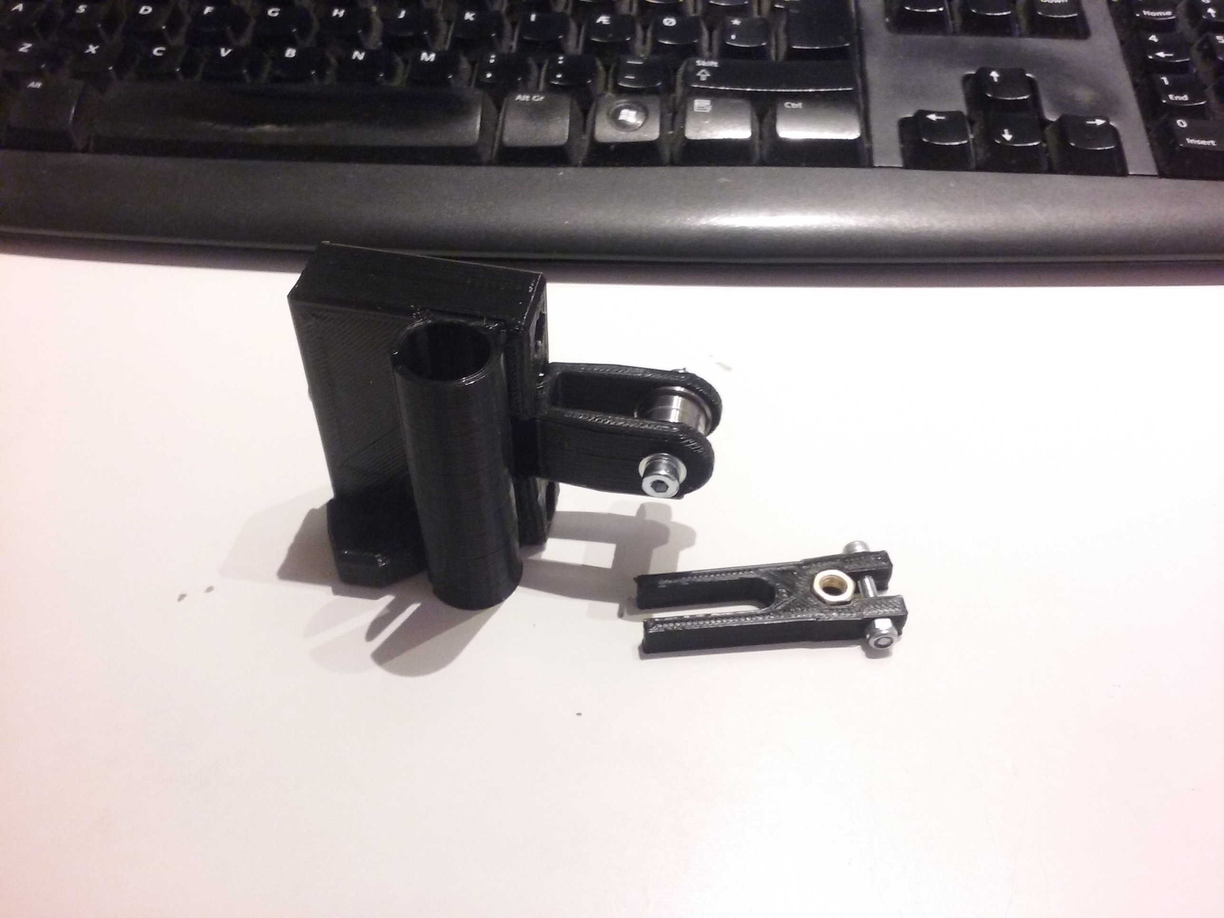
- Put these to a side for now

